Task 7 Output

LS1_color_5_svd, k=10, image_id = 0

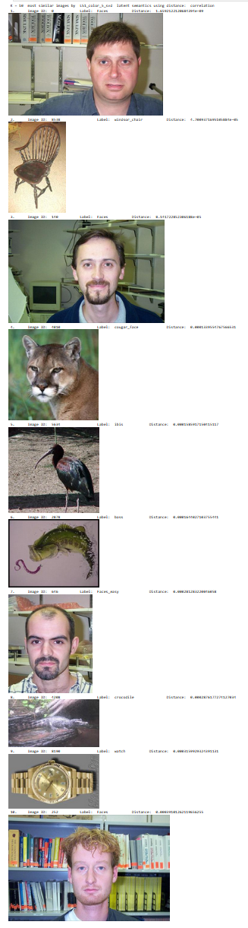

LS1_color_5_svd, k=10, image_id = 8676

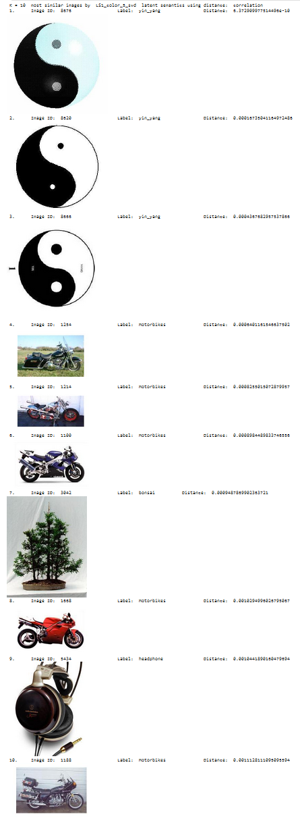

LS2_resnet_5_cpd, k=10, image_id = 0

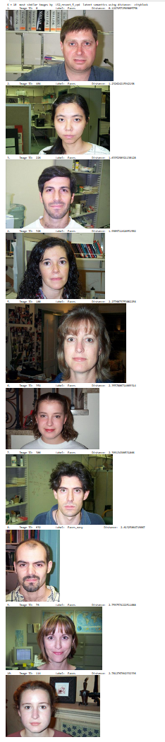
LS2_resnet_5_cpd, k=10, image_id = 8676

